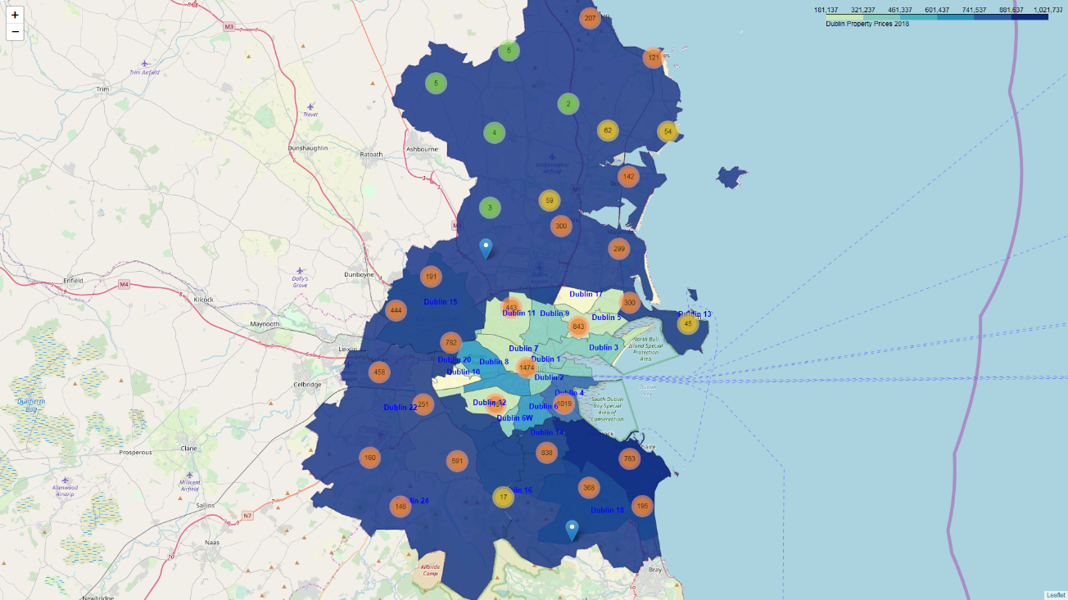

Dublin Property Price Register Insights

Location recommendations based on 2018 Property Sales

Venkatachalam Ramachandran | Capstone Project | November 1, 2018

## Abstract

This report is an attempt to use Property Price Register data pertaining to Ireland available for download as an open CSV dataset from the [PRSA](https://propertypriceregister.ie/website/npsra/ppr/npsra-ppr.nsf/Downloads/PPR-ALL.zip/$FILE/PPR-ALL.zip) website to derive insights with a view to recommend neighbourhood locations in Dublin, Ireland conducive to investment options for buy-to-let properties and/or targeted business opportunities. Data from the indicated dataset has been filtered to restrict records to those pertaining to property sales in County Dublin for the year 2018 and has been enhanced by addition of GPS location co-ordinates for every property sold in Dublin in 2018 (01-Jan-2018 to 30-Sep-2018) also leveraging Foursquare location data to derive popular nearby venues in Dublin neighbourhoods.

## IntroDUCTION

As a longtime resident of Dublin, Ireland – I have recently been interested in looking at options for residential buy-to-let properties and settling on a choice in terms of area/locality has always been a challenge. As a layperson the obvious choice is to come up with a small list of areas/localities conducive to letting and review popular property online resources – myhome.ie and daft.ie to name a couple – to sift through various available properties and make an informed decision.

Now that I am a bit richer for experience in terms of tools and techniques used in data science, the objective was to gather information based on property selling prices in the recent past and apply tools and techniques as guidance to evaluate optimally suited investment properties with a view to letting.

## Business Problem

The problem that this project seeks to address using data science uses data from the openly available Ireland Property Price Register providing a list of properties with their location and selling prices. The questions that can possibly be answered would be along the lines of

* What are indicative prices of properties in a given neighbourhood and how actively are properties changing hands?
* Which are the neighbourhoods with good public transport links which could potentially be attractive to tenants?
* Do the presence of popular amenities and services have a strong correlation with property prices?

The interested audience for the insights provided would primarily be like-minded buyers/investors with business providers also benefiting from the volume of properties sold, the ability of a neighbourhood to cater for specific niche business and the level of competition being faced.

## Data

The data primarily used for this exercise is a [filtered download](https://propertypriceregister.ie/website/npsra/pprweb.nsf/PPRDownloads?OpenForm) of residential property price register for Dublin from January to September 2018. The resulting CSV dataset is then scrubbed and sanitized before using a combination of geo-location APIs to determine and assign geolocation co-ordinates and neighbourhood classifiers for the properties. This is then enhanced with data from foursquare to list popular venues/places of interest and using classifiers to broadly classify the properties into groups/buckets.

The choice of the first three quarters in 2018 are broadly dictated by the time-consuming process of assigning geolocation co-ordinates based on data, that sometimes is missing key parts of address and post code.

## RESULTS

## DISCUSSION

## CONCLUSION

## References / Acknowledgements